SECTION 5: ECONOMIC PROFILE

INTRODUCTION

The purpose of this section is to provide a broad economic analysis of the regional and local economy of the Makhado Local Municipal Area. It is important to understand the economy of the Study Area within the context of the broader region so that comparisons and linkages with the broader economic community can be identified. Each economic sector will be analysed and discussed in terms of a sectoral analysis and will also identify the sectors with growth potential.

In the following paragraphs the provincial context is discussed according to the Gross Value Added (GVA) and labour statistics of the Study Area which are compared to those of the Limpopo Province and to South Africa. Thereafter, the economic activity in the Study Area is highlighted, and the implications thereof for economic growth are detailed. This section concludes with a summary of the relevant findings. GGP refers to the value of all final goods and services produced during a year within the boundaries of a specific area. GGP is generally used to measure the level of economic activity in that area. The term GGVA (Gross Geographic Value Added), technically differs from GGP, but practically indicates the same. GGVA can be calculated from the production, demand and income sides of the economy. The difference between GGVA and GDP lies in taxes and subsidies not being included in the GGVA calculation. By means of analyzing the GGVA, the strongest economic sectors in the local economy are identified.

The economy of an area can be divided into three main categories, namely primary, secondary and tertiary sectors. Each of these categories is further sub-divided into different economic sectors. These different sectors are defined as follows:

- Primary Sector
      - Agriculture
      - Mining
- Secondary Sector
      - Manufacturing
      - Electricity/Water/Gas
      - Construction
- Tertiary Sector
      - Trade
      - Transport/Communication/Storage
      - Financial & business services
      - Social services including Government Services.

This section will be discussed under the following headings:

- Limpopo Province in Relation to South Africa Perspective
- Vhembe District Municipality in Relation to Limpopo Province Perspective
- Makhado Local Municipality in Relation to Vhembe District Municipality Perspective
- Conclusion

LIMPOPO PROVINCE IN RELATION TO SOUTH AFRICA PERSPECTIVE

The purpose of this sub-section is to determine the economic importance of Limpopo Province within South Africa. To determine the economic context of the above economies, the most important economic and labour indicators are discussed.

GROSS VALUE ADDED (GVA)

The following table illustrates the GVA contribution of each province to total production in South Africa.

Table 5.1: GVA Contribution by province to National GVA, Constant Prices, 2000
Province | Percentage Contribution to GVA in South Africa
Province | 1993 | 1998 | 2003
Western Cape | 14.1% | 14.0% | 14.5%
Eastern Cape | 8.4% | 8.2% | 8.0%
Northern Cape | 2.4% | 2.4% | 2.2%
Free State | 5.9% | 5.4% | 5.1%
Kwazulu-Natal | 16.5% | 16.5% | 16.4%
North West | 6.9% | 6.7% | 6.3%
Gauteng | 32.8% | 33.3% | 34.2%
Mpumalanga | 6.6% | 6.8% | 6.6%
Limpopo | 6.3% | 6.7% | 6.7%
South Africa | 100% | 100% | 100%
Source: Urban-Econ Calculations based on Quantec Database, 2005

The Limpopo Province contributes only 6.7% to total production in South Africa. This share is exceeded by all of the other provinces in South Africa, except for the Free State with 5.9% and the Northern Cape with 2.4%.

The following table illustrates the province’s growth in GVA.

Table 5.2: Percentage Growth in GVA, 1993-2003
Province | Percentage Average Annual Growth Rate
Province | 1993-1998 |  | 1998-2003
Western Cape | 2.4% | 4.1%
Eastern Cape | 2.0% | 2.9%
Northern Cape | 2.6% | 1.4%
Free State | 0.8% | 2.3%
Kwazulu-Natal | 2.6% | 3.2%
North West | 2.0% | 2.0%
Gauteng | 2.9% | 3.8%
Mpumalanga | 3.3% | 2.5%
Limpopo | 3.7% | 3.3%
South Africa | 2.6% | 3.3%
Source: Urban-Econ Calculations based on Quantec Database, 2005

During 1993 to 1998 Limpopo experienced an average annual growth rate of 3.7% in GVA, compared to 2.6% growth for South Africa. Limpopo experienced the highest growth rate for this period. This indicates that Limpopo performed very well during the 1990’s and fairly well (equal to the country’s average) from 1998 to 2003 when compared to the rest of the country.

The economic sectors in an area are distributed into three main sectors namely the primary, secondary and tertiary sectors. The primary sector consists of the agricultural and the mining activities. The manufacturing, electricity, construction and the trade activities form the secondary sector while the tertiary sector consists of the transport, financial and services activities. Other tools utilised to measure the performance of a given economy are described below.

Production in South Africa by economic sector is provided in Table 5.3.

Table 5.3: South Africa: GVA, Constant Prices 2000
Sector
GVA SA
GVA SA | 1993 | 1998 | 2003
Agriculture, forestry and fishing | 3.51% | 3.16% | 2.89%
Mining | 9.35% | 8.32% | 7.25%
Manufacturing | 18.78% | 18.72% | 18.19%
Electricity & water | 2.77% | 2.84% | 2.40%
Construction | 2.79% | 2.59% | 2.68%
Wholesale & retail trade; catering and accommodation | 13.44% | 13.50% | 14.85%
Transport & communication | 7.49% | 9.08% | 10.69%
Finance and business services | 17.17% | 18.43% | 20.34%
Community, social and other personal services | 5.74% | 6.04% | 6.14%
General government services | 18.96% | 17.34% | 14.56%
Total | 100% | 100% | 100%

Figure 5.1
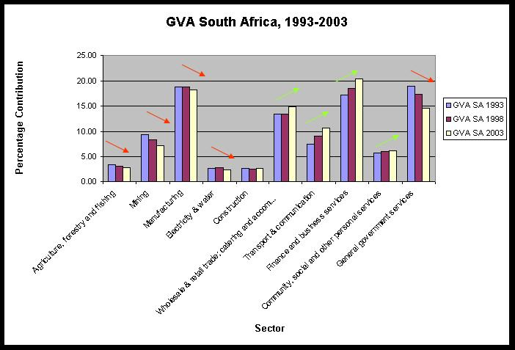

Source: Urban-Econ Calculations based on Quantec Database, 2005

From Table 5.3 it is evident that the following sectors contributed the most to South Africa’s GVA. They include, inter alia, the following:

- Manufacturing
- Wholesale & retail trade; catering and accommodation
- Finance and business services
- General government services
- Transport & Communication

It is also evident that the following sectors indicated a positive growth rate (Figure 5.1). These sectors include, inter alia, the following:

- Wholesale & retail trade; catering and accommodation
- Transport & Communication
- Community, social and other personal services
- Finance and business services

Production in Limpopo by economic sector is provided in Table 5.4.

Table 5.4: Limpopo: GVA, Constant Prices 2000
Sector
GVA Limpopo
GVA Limpopo | 1993 | 1998 | 2003
Agriculture, forestry and fishing | 2.88% | 2.65% | 2.64%
Mining | 25.87% | 23.82% | 25.22%
Manufacturing | 4.35% | 4.03% | 3.84%
Electricity & water | 2.81% | 3.15% | 3.03%
Construction | 2.30% | 2.16% | 1.84%
Wholesale & retail trade; catering and accommodation | 12.97% | 12.66% | 13.44%
Transport & communication | 5.77% | 7.34% | 10.82%
Finance and business services | 18.34% | 17.57% | 15.85%
Community, social and other personal services | 5.02% | 4.99% | 5.07%
General government services | 19.69% | 21.61% | 18.24%
Total | 100% | 100% | 100%

Figure 5.2
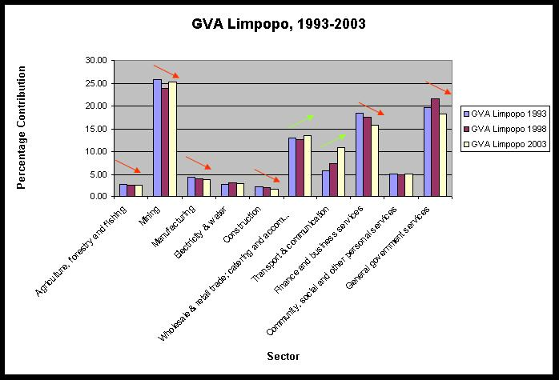

Source: Urban-Econ Calculations based on Quantec Database, 2005

Within the Limpopo province the important economic activities are the mining, finance and business services, general government services, and wholesale and retail trade. These sectors contribute approximately 66.7% share to Limpopo’s production.

These trends are very similar to the national economy. The dominant sectors in the national GVA and Limpopo GVA are similar but experience different growth patterns.

LOCATION QUOTIENT

A location quotient is a device for comparing a sub-region’s share in a particular activity with its percentage share in some basic regional aggregate. A value of ore than 1 implies that the sector in a certain region has a comparative advantage compared to the rest of the region.

Table 5.5 below indicates in which sectors Limpopo has a comparative advantage when compared to the national sectors. The relative performance of the various economic sectors in terms of growth recorded is examined in the subsequent table. This analysis is aimed at revealing comparative differences in terms of the rate at which the various sectors expand in relation to the broader national economy.

Table 5.5: Limpopo Location Quotient and Sectoral Growth, 1993-2003
Sector | Location Quotient |  |  |  | Sectoral Growth
Sector | 1993 | 1998 | 2003 | Increase/ Decrease in Comparative Advantage | 1993-1998 | 1998-2003 | Increase/ Decrease in Sectoral Growth
Agriculture, forestry and fishing | 0.82 | 0.84 | 0.91 | ▲ | 2.0% | 3.2% | ▲
Mining | 2.77 | 2.86 | 3.48 | ▲ | 2.0% | 4.4% | ▲
Manufacturing | 0.23 | 0.22 | 0.21 | ▼ | 2.2% | 2.3% | ▲
Electricity & water | 1.01 | 1.11 | 1.26 | ▲ | 6.1% | 2.5% | ▼
Construction | 0.83 | 0.83 | 0.68 | ▼ | 2.4% | 0.0% | ▼
Wholesale & retail trade; catering and accommodation | 0.97 | 0.94 | 0.91 | ▼ | 3.2% | 4.5% | ▲
Transport & communica - tion | 0.77 | 0.81 | 1.01 | ▲ | 8.8% | 11.6% | ▲
Finance and business services | 1.07 | 0.95 | 0.78 | ▼ | 2.8% | 1.2% | ▼
Community, social and other personal services | 0.87 | 0.83 | 0.83 | ▼ | 3.6% | 3.6% | -
General government services | 1.04 | 1.25 | 1.25 | ▲ | 5.7% | -0.2% | ▼
Source: Urban-Econ Calculations based on Quantec Database, 2005

From Table 5.5 above it can be concluded that the Limpopo Province has a comparative advantage and experience an increasing growth rate in the following sectors:

- Mining Wholesale & retail trade; catering and accommodation
- Transport & communication Mining

Other sectors which indicated a comparative advantage but experienced decreasing sectoral growth include inter alia, the following:

- Electricity & water, and
- General government services

Although a comparative advantage may be experienced in the above-mentioned sectors, Table 5.6 below illustrates the contribution of Limpopo’s sectors towards the GVA of South Africa. It is emphasized that the information contained in the following table represents the proportional contribution of the individual sectors to the national sectors.

Table 5.6: Limpopo Province Contribution to GVA of South Africa per sector
Sector | Limpopo Contribution to National GVA per sector, 1993-2003
Sector | 1993 | 1998 | 2003 | Increase/ Decrease to National GVA
Agriculture, forestry and fishing | 5.18 | 5.61 | 6.08 | ▲
Mining | 17.51 | 19.13 | 23.19 | ▲
Manufacturing | 1.46 | 1.44 | 1.41 | ▼
Electricity & water | 6.42 | 7.41 | 8.41 | ▲
Construction | 5.22 | 5.56 | 4.57 | ▼
Wholesale & retail trade; catering and accommodation | 6.11 | 6.27 | 6.04 | ▼
Transport & communication | 4.88 | 5.40 | 6.75 | ▲
Finance and business services | 6.76 | 6.37 | 5.20 | ▼
Community, social and other personal services | 5.54 | 5.52 | 5.50 | ▼
General government services | 6.57 | 8.32 | 8.35 | ▲
Total | 6.33 | 6.68 | 6.67
Source: Urban-Econ Calculations based on Quantec Database, 2005

The primary sector contributes approximately 18.31% percent to the South Africa’s primary sector economy. The Mining sector of Limpopo is the most important sector and also contributes the most to the total production of the primary sector of South Africa with 23.19 percentage points. The smallest contribution to total production is by the secondary sector, contributing 3.88% to South Africa’s secondary Economy. The tertiary sector of the Limpopo contributes 6.44% to South Africa’s tertiary Economy with the general government services being the biggest in the tertiary sector.

In terms of the mining sectors, the Limpopo Province plays a significant role with regards to the National economy’s mining sector.

Limpopo contributes approximately 6.67% towards the overall national economy. This contribution has remained relatively stable during the period under review.

The following sectors experienced an increase in the sectoral contribution to the overall national performance. They include, inter alia, the following:

- Mining
- General government services
- Transport & communication
- Electricity & water
- Agriculture, forestry and fishing

It is vitally important to realize that the provincial economy outperformed the national economy, i.e. was one of the driving economies in a national context with regards to certain sectors. It is however necessary to investigate the role of the Vhembe District Municipal economy in the Provincial context.

VHEMBE DISTRICT MUNICIPALITY IN RELATION TO LIMPOPO PROVINCE PERSPECTIVE

The purpose of this sub-section is to determine the economic importance of Vhembe District Municipality within the Limpopo Province. To determine the economic context of the above economies, the most important economic and labour indicators are discussed.

GROSS VALUE ADDED (GVA)

The following table illustrates the GVA contribution of each municipal district to total production in Limpopo.

Table 5.7: GVA Contribution of District Municipalities
District Municipality | Percentage Contribution to GVA in Limpopo
District Municipality | 1993 | 1998 | 2003
Mopani District Municipality | 21.88% | 20.70% | 19.73%
Vhembe District Municipality | 18.13% | 18.19% | 17.45%
Capricorn District Municipality | 21.66% | 23.15% | 23.89%
Waterberg District Municipality | 23.82% | 23.97% | 25.59%
Sekhukhune Cross Boundary District Municipality | 7.66% | 7.38% | 7.28%
Bohlabela District Municipality | 6.86% | 6.61% | 6.05%
Limpopo | 100% | 100% | 100%
Source: Urban-Econ Calculations based on Quantec Database, 2005

The Vhembe District Municipality’s contribution decreased from 18.13% to 17.45% to total production in Limpopo. This share is exceeded by all of the other Municipal District Municipalities except for Sekhukhune and Bohlabela District Municipalities This implies that Vhembe District Municipality is the fourth biggest District Municipality in Limpopo Province.

The following table illustrates Vhembe District Municipality’s growth in GVA.

Table 5.8: Percentage Average Annual Growth Rate
District Municipality | Percentage Average Annual Growth Rate
District Municipality | 1993-1998 |  | 1998-2003
Mopani District Municipality | 2.6% | 2.3%
Vhembe District Municipality | 3.8% | 2.4%
Capricorn District Municipality | 5.1% | 3.9%
Waterberg District Municipality | 3.8% | 4.6%
Sekhukhune Cross Boundary District Municipality | 2.9% | 3.0%
Bohlabela District Municipality | 2.9% | 1.5%
Limpopo | 3.7% | 3.3%
Source: Urban-Econ Calculations based on Quantec Database, 2005

During 1993 to 1998 Vhembe DM experienced an average annual growth rate of 3.8% in GVA, compared to 3.7% growth for Limpopo. Vhembe DM experienced the second highest growth rate for this period. This indicates that Vhembe DM performed very well from 1993 to 1998 and fairly poor (below the province’s average) from 1998 to 2003 when compared to the rest of the Province. Vhembe District Municipality’s percentage annual growth rate declined from 3.8% to 2.4% respectively.

The economic sectors in an area are distributed into three main sectors namely the primary, secondary and tertiary sectors. The primary sector consists of the agricultural and the mining activities. The manufacturing, electricity, construction and the trade activities form the secondary sector while the tertiary sector consists of the transport, financial and services activities. Other tools utilised to measure the performance of a given economy are described below.

Production in Vhembe District Municipality by economic sector is provided in Table 5.9 below.

Table 5.9: Vhembe District Municipality: GVA, Constant Prices 2000
Sector
GVA Vhembe District Municipality
GVA Vhembe District Municipality | 1993 | 1998 | 2003
Agriculture, forestry and fishing | 2.67% | 2.42% | 2.48%
Mining | 9.99% | 9.96% | 11.51%
Manufacturing | 4.43% | 3.68% | 3.24%
Electricity & water | 2.25% | 2.60% | 2.71%
Construction | 3.10% | 2.61% | 2.10%
Wholesale & retail trade; catering and accommodation | 13.95% | 13.07% | 13.88%
Transport & communication | 6.75% | 8.80% | 13.76%
Finance and business services | 20.72% | 18.89% | 16.80%
Community, social and other personal services | 5.75% | 5.66% | 5.96%
General government services | 30.38% | 32.32% | 27.57%
Total | 100% | 100% | 100%

Figure 5.3
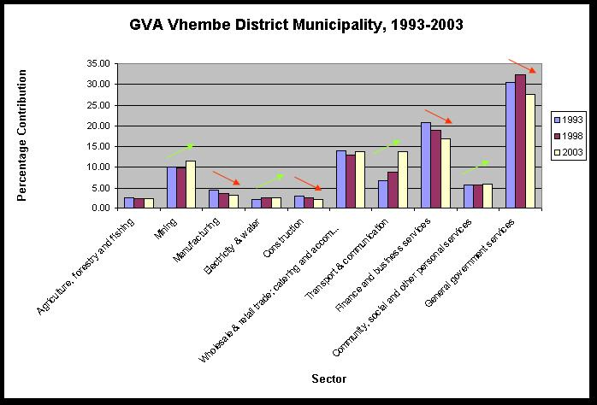

Source: Urban-Econ Calculations based on Quantec Database, 2005

Within Vhembe District Municipality the important economic activities are the mining, wholesale & retail trade; catering and accommodation, finance and business services, general government services, and transport & communication. These sectors contribute approximately 73.42% share to Vhembe’s production.

These trends are very similar to the national economy. The dominant sectors in the national GVA and Limpopo GVA are similar but experience different growth patterns.

LOCATION QUOTIENT

Table 5.10 below indicates in which sectors Vhembe DM has a comparative advantage when compared to the provincial sectors. The relative performance of the various economic sectors in terms of growth recorded is examined in the subsequent table. This analysis is aimed at revealing comparative differences in terms of the rate at which the various sectors expand in relation to the broader provincial economy.

Table 5.10: Vhembe Location Quotient and Sectoral Growth, 1993-2003
Sector | Location Quotient |  |  |  | Sectoral Growth
Sector | 1993 | 1998 | 2003 | Increase/ Decrease in Comparative Advantage | 1993-1998 | 1998-2003 | Increase/ Decrease in Sectoral Growth
Agriculture, forestry and fishing | 0.93 | 0.91 | 0.94 | ▲ | 1.8 | 2.9 | ▲
Mining | 0.39 | 0.42 | 0.46 | ▲ | 3.7 | 5.4 | ▲
Manufacturing | 1.02 | 0.91 | 0.84 | ▼ | 0.0 | -0.2 | ▼
Electricity & water | 0.80 | 0.83 | 0.89 | ▲ | 6.9 | 3.2 | ▼
Construction | 1.35 | 1.21 | 1.14 | ▼ | 0.2 | -1.9 | ▼
Wholesale & retail trade; catering and accommodation | 1.08 | 1.03 | 1.03 | ▼ | 2.4 | 3.7 | ▲
Transport & communica - tion | 1.17 | 1.20 | 1.27 | ▲ | 9.4 | 12.0 | ▲
Finance and business services | 1.13 | 1.07 | 1.06 | ▼ | 1.9 | 0.0 | ▼
Community, social and other personal services | 1.15 | 1.14 | 1.18 | ▲ | 3.4 | 3.5 | ▲
General government services | 1.54 | 1.50 | 1.51 | ▼ | 5.1 | -0.8 | ▼
Source: Urban-Econ Calculations based on Quantec Database, 2005

From Table 5.10 above it can be concluded that the Vhembe District Municipality has a comparative advantage and experience an increasing growth rate in the following sectors:

- Community, social and other personal services
- Transport & communication
- Wholesale & retail trade; catering and accommodation

Other sectors which indicated a comparative advantage but experienced decreasing sectoral growth include inter alia, the following:

- Construction
- Finance and business services, and
- General government services

Although a comparative advantage may be experienced in the above-mentioned sectors, Table 5.11 below illustrates the contribution of Vhembe DM’s sectors towards the GVA of Limpopo. It is emphasized that the information contained in the following table represents the proportional contribution of the individual sectors to the provincial sectors.

Table 5.11: Vhembe DM Contribution to GVA of Limpopo per sector
Sector | Vhembe DM Contribution to Limpopo GVA per sector, 1993-2003
Sector | 1993 | 1998 | 2003 | Increase/ Decrease to Provincial GVA
Agriculture, forestry and fishing | 16.83 | 16.62 | 16.40 | ▼
Mining | 7.00 | 7.60 | 7.96 | ▲
Manufacturing | 18.49 | 16.57 | 14.69 | ▼
Electricity & water | 14.49 | 15.03 | 15.60 | ▲
Construction | 24.43 | 21.98 | 19.95 | ▼
Wholesale & retail trade; catering and accommodation | 19.49 | 18.77 | 18.02 | ▼
Transport & communication | 21.19 | 21.79 | 22.19 | ▲
Finance and business services | 20.48 | 19.54 | 18.49 | ▼
Community, social and other personal services | 20.78 | 20.65 | 20.52 | ▼
General government services | 27.96 | 27.19 | 26.38 | ▼
Total | 18.13 | 18.19 | 17.45 | ▼
Source: Urban-Econ Calculations based on Quantec Database, 2005

The primary sector of Vhembe DM contributes approximately 8.76% percent to Limpopo’s primary sector economy. The General Government sector of Vhembe is the most important sector and also contributes the most to the total production of Limpopo with 26.38 percentage points. This sector’s contribution to Limpopo’s GVA declined from 1993 to 2003. The secondary sector of Vhembe DM contributes 17.27% to Limpopo’s secondary Economy with Construction being the biggest secondary sector.

Vhembe contributes approximately 17.45% towards the overall provincial economy. This contribution has declined during the period under review.

The following sectors experienced an increase in the sectoral contribution to the overall national performance. They include, inter alia, the following:

- Mining
- Transport & communication, and
- Electricity & water

It is vitally important to realize that the district economy outperformed the provincial economy during 1993 to 1998. The provincial economy however outperformed the district economy during 1998 to 2003. This indicates that Vhembe District Municipality’s economy experienced a decrease in the contribution towards the provincial GVA and therefore is to a lesser extent one of the driving economies in a provincial context with regards to certain sectors. It is however necessary to investigate the role of the Makhado Municipal economy in the Municipal District context.

MAKHADO LOCAL MUNICIPALITY IN RELATION TO VHEMBE DISTRICT MUNICIPALITY PERSPECTIVE

The purpose of this sub-section is to determine the economic importance of Makhado Local Municipality within the Vhembe District Municipality. To determine the economic context of the above economies, the most important economic and labour indicators are discussed.

GROSS VALUE ADDED (GVA)

Similar to the preceding discussion of the contribution of the Vhembe economy to the broader economy, namely the provincial economy of Limpopo, this sub-section discusses the Makhado economy in relation to the Vhembe economy.

A total of four local municipalities constitute the Vhembe District and are:

- Musina Local Municipality
- Mutale Local Municipality
- Thulamela Local Municipality
- Makhado Local Municipality

The relative percentage contributions towards the total GVA of Vhembe District Municipality are presented in Table 5.12.

Table 5.12: Percentage Contribution to GVA in Vhembe :
Municipality | Percentage Contribution to GVA in Vhembe
Municipality | 1993 | 1998 | 2003
Musina | 9.98% | 9.82% | 10.80%
Mutale | 7.22% | 7.85% | 8.72%
Thulamela | 41.08% | 40.09% | 37.20%
Makhado | 41.71% | 42.24% | 43.27%
Vhembe | 100% | 100% | 100%
Source: Urban-Econ Calculations based on Quantec Database, 2005

Makhado Municipality’s contribution to the GVA of Vhembe increased from 41.71% to 43.27% from 1993 to 2003. This share is the biggest when compared to the other local municipalities. This implies that Makhado Local Municipality contributes the most to the GVA of the Vhembe economy and is therefore the driving economy in this region.

The following table illustrates Makhado Local Municipality’s growth in GVA.

Table 5.13: Percentage Average Annual Growth in GVA for Makhado Municipality
District Municipality | Percentage Average Annual Growth Rate
District Municipality | 1993-1998 |  | 1998-2003
Musina | 3.4 | 4.4
Mutale | 5.5 | 4.6
Thulamela | 3.3 | 0.9
Makhado | 4.0 | 2.9
Vhembe | 3.8 | 2.4
Source: Urban-Econ Calculations based on Quantec Database, 2005

During 1993 to 1998 Makhado Local Municipality experienced an average annual growth rate of 4.0% in GVA, compared to 3.8% growth for Vhembe DM. Makhado Local Municipality experienced the second highest growth rate for this period. This indicates that Makhado Local Municipality performed very well from 1993 to 1998 and fairly poor (but still above Vhembe’s average of 2.4%) from 1998 to 2003 when compared to the rest of the District Municipality. Makhado Local Municipality’s percentage annual growth rate declined from 4.0% to 2.9% respectively, which illustrates the need for economic development that will broaden its economic base and increase economic growth.

Production in Makhado Local Municipality by economic sector is provided in Table 5.14 below.

Table 5.14: Makhado Local Municipality: GVA, Constant Prices 2000
Sector
GVA Makhado Local Municipality
GVA Makhado Local Municipality | 1993 | 1998 | 2003
Agriculture, forestry and fishing | 3.29% | 2.84% | 2.73%
Mining | 3.21% | 2.47% | 2.27%
Manufacturing | 5.13% | 4.24% | 3.64%
Electricity & water | 2.20% | 2.79% | 3.04%
Construction | 2.95% | 2.56% | 2.10%
Wholesale & retail trade; catering and accommodation | 18.74% | 18.04% | 19.53%
Transport & communication | 9.07% | 10.75% | 15.52%
Finance and business services | 22.79% | 20.71% | 18.36%
Community, social and other personal services | 6.48% | 6.98% | 7.93%
General government services | 26.13% | 28.61% | 24.89%
Total | 100% | 100% | 100%

Figure 5.4
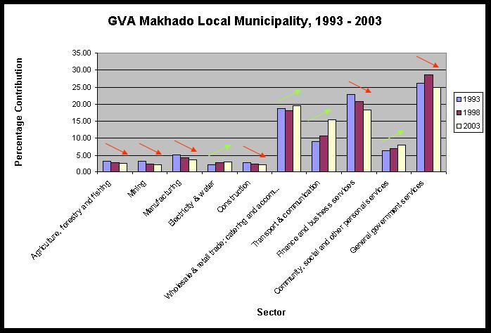

Source: Urban-Econ Calculations based on Quantec Database, 2005

Within Makhado Local Municipality the important economic activities are the wholesale & retail trade; catering and accommodation; finance and business services, general government services, and transport & communication. These sectors contribute approximately 78.30% share to Makhado’s production.

LOCATION QUOTIENT

Table 5.15 below indicates in which sectors Makhado Local municipality has a comparative advantage when compared to Vhembe District sectors. The relative performance of the various economic sectors in terms of growth recorded is examined in the subsequent table. This analysis is aimed at revealing comparative differences in terms of the rate at which the various sectors expand in relation to the broader district economy.

Table 5.15: Makhado Location Quotient and Sectoral Growth, 1993-2003
Sector | Location Quotient |  |  |  | Sectoral Growth
Sector | 1993 | 1998 | 2003 | Increase/ Decrease in Comparative Advantage | 1993-1998 | 1998-2003 | Increase/ Decrease in Sectoral Growth
Agriculture, forestry and fishing | 1.23 | 1.17 | 1.10 | ▼ | 1.0 | 2.1 | ▲
Mining | 0.32 | 0.25 | 0.20 | ▼ | -1.2 | 1.1 | ▲
Manufacturing | 1.16 | 1.15 | 1.12 | ▼ | 0.2 | -0.2 | ▼
Electricity & water | 0.98 | 1.07 | 1.12 | ▲ | 9.1 | 4.7 | ▼
Construction | 0.95 | 0.98 | 1.00 | ▲ | 1.1 | -1.1 | ▼
Wholesale & retail trade; catering and accommodation | 1.34 | 1.38 | 1.41 | ▲ | 3.2 | 4.6 | ▲
Transport & communica - tion | 1.34 | 1.22 | 1.13 | ▼ | 7.6 | 10.8 | ▲
Finance and business services | 1.10 | 1.10 | 1.09 | ▼ | 2.1 | 0.5 | ▼
Community, social and other personal services | 1.13 | 1.23 | 1.33 | ▲ | 5.6 | 5.6 | -
General government services | 0.86 | 0.89 | 0.90 | ▲ | 5.9 | 0.1 | ▼
Source: Urban-Econ Calculations based on Quantec Database, 2005

From Table 5.15 above it can be concluded that Makhado Local Municipality has a comparative advantage and experience an increasing growth rate in the following sectors:

- Wholesale & retail trade; catering and accommodation
- Transport & communication

Other sectors which indicated a comparative advantage but experienced decreasing sectoral growth include inter alia, the following:

- Agriculture, forestry and fishing
- Manufacturing
- Electricity & water
- Construction
- Finance and business services

The trends in these sectors are important as it provides an indication of the future movements within the comparative advantages.

- Agriculture
      - The comparative advantage of this sector has decreased slightly but its sectoral growth improved in the medium term
- Manufacturing
      - The comparative advantage of this sector has remained stable but experienced a slight decrease in sectoral growth
- Electricity
      - The comparative advantage of this sector has increased with a decline in sectoral growth from 1993 to 2003.
- Wholesale & retail trade; catering and accommodation
      - The comparative advantage of this sector has increased and experienced an increase in sectoral growth from 3.2 to 4.6%.
- Transport & communication
      - Similar to the wholesale and retail trade sector, the comparative advantage of this sector has increased and experienced an increase in sectoral growth from 7.6 to 10.8% fro the period under study.
- Construction; Finance and business services
      - These sectors also indicate a comparative advantage but experienced a decline in sectoral growth from 1993 to 2003.

Although a comparative advantage may be experienced in the above-mentioned sectors, Table 5.16 below illustrates the contribution of Makhado Local Municipality’s sectors towards the GVA of Vhembe District Municipality. It is emphasized that the information contained in the following table represents the proportional contribution of the individual sectors to the Municipal District sectors.

Table 5.16: Makhado Municipality Contribution to GVA of Vhembe District Municipality per sector
Sector | Makhado LM Contribution to Vhembe DM GVA per sector, 1993-2003
Sector | 1993 | 1998 | 2003 | Increase/ Decrease to District GVA
Agriculture, forestry and fishing | 51.44 | 49.51 | 47.56 | ▼
Mining | 13.39 | 10.50 | 8.53 | ▼
Manufacturing | 48.29 | 48.77 | 48.61 | ▲
Electricity & water | 40.81 | 45.29 | 48.54 | ▲
Construction | 39.66 | 41.42 | 43.20 | ▲
Wholesale & retail trade; catering and accommodation | 56.06 | 58.32 | 60.90 | ▲
Transport & communication | 56.02 | 51.62 | 48.82 | ▼
Finance and business services | 45.87 | 46.30 | 47.30 | ▲
Community, social and other personal services | 47.01 | 52.05 | 57.58 | ▲
General government services | 35.88 | 37.39 | 39.06 | ▲
Total | 41.71 | 42.24 | 43.27 | ▲
Source: Urban-Econ Calculations based on Quantec Database, 2005

The smallest contribution to total production is by the primary sector. The primary sector contributes approximately 15.45% percent to Vhembe’s primary sector economy. The General Government sector of Vhembe is the most important sector and also contributes the most to the total production of the tertiary sector of Vhembe with 45.05%. The biggest sector is the secondary sector of Makhado which contributes 55.87% to Vhembe’s Economy with the Retail trade as the biggest secondary sector.

Makhado Local municipality contributes approximately 43.27% towards Vhembe District Municipality’s economy. This contribution has increased from 41.71% in 1993 to 43.27% in 2003.

The following sectors experienced an increase in the sectoral contribution to the overall district performance. They include, inter alia, the following:

- Manufacturing
- Electricity & water
- Construction
- Wholesale & retail trade; catering and accommodation
- Finance and business services
- Community, social and other personal services
- General government services

The above-mentioned sectors contribute a large amount to Vhembe District Municipality’s GVA, hence the importance of Makhado Municipality as a driving economy in the district context.

Key points

- Makhado is the largest economy in the district as it contributes most to the district GVA
- Only the Agriculture, forestry and fishing; Mining; Wholesale and retail trade; and Transport & Communication sectors experienced an increase in sectoral growth from 1993 to 2003. The remainder of the economic sectors experience decreasing economic growth

LABOUR FORCE

This section addresses the composition of the labour force in Makhado, important indicators of the labour force, the quality of the labour force and the distribution of the formal labour force in the different economic sectors. It is necessary to describe the labour situation in the area as these indicators also give insight into the economic and social conditions present in the area.

The percentage of the labour force in the Limpopo Province represents 6.7% of the labour force of South Africa (see Figure 5.5). All of the other provinces accommodate a larger percentage of the South African labour force, except for the Free State and Northern Cape.

Figure 5.5: Labour Force Distribution by Province, 2003
 | Labour force distribution by province, 2002  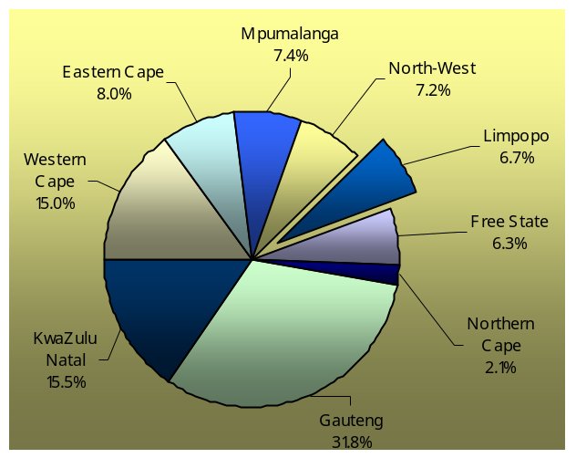
  Province | Labour force distribution
  Gauteng | 31.8%
  Kwazulu Natal | 15.5%
  Western Cape | 15%
  Eastern Cape | 8%
  Mpumalanga | 7.4%
  North-West | 7.2%
  Limpopo | 6.7%
  Free State | 6.3%
  Northern Cape | 2.1%
Source: Urban-Econ Calculations based on Quantec Database, 2005

COMPOSITION OF THE LABOUR FORCE

Table 5.17 illustrates the composition of the labour force in South Africa, Limpopo and Makhado. The composition is provided according to employment sector and gender.

Table 5.17: Composition of the Lab our Force in South Africa, Limpopo and the Study Area, 2003
Total Labour Force | South Africa | Limpopo | Study Area
Formal | 27.3% | 15.8% | 15.5%
Informal | 6.4% | 6.9% | 6.6%
Total Employment | 33.7% | 22.7% | 22.1%
Not EA | 42.3% | 55.7% | 55.9%
Unemployment | 24.0% | 21.6% | 21.9%
Total Labour Force | South Africa | Limpopo | Study Area
Males | 47.6% | 43.7% | Unknown
Females | 52.4% | 56.3% | Unknown
Source: Urban-Econ Calculations based on Municipal Demarcation Board Statistics, 2005

The formal sector in the Limpopo Province represents about 15.8% of the labour force. In South Africa this sector represents 27.3%. Although this is the largest share, the unemployment rate of approximately 21.6% in the Limpopo Province and 24% nationally, represents a disturbingly large share of the labour force. The informal sector in Limpopo represents a larger share (6.9%) of the labour force than is the case in South Africa (6.4%).

Unemployment is an indication of the balance between supply and demand of labour. A high level of unemployment indicates that the supply of labour is more than the demand for labour in an area. Economic activities create employment opportunities and the type of production technique, as well as the nature of the production, significantly influences the ratio of the contribution of each economic activity towards GVA and the corresponding employment creation of each activity. The unemployed in the Limpopo represent 21.6% of the labour force, which is a significantly large share of the labour force. In South Africa this share is slightly higher at 24% of the labour force that are unemployed. About 49.8% of people in the Study Area (and approximately 21.9% of the labour force) in the Study Area is unemployed. This is an indication that inadequate employment opportunities exist in the Study Area to sustain the local labour force.

LABOUR INDICATORS

The dependency rate indicates the amount of people dependent on one person in the labour force of an area. The participation rate indicates the percentage of the economically active population that are part of the labour force. This is an important measurement of the absorption capacity in an area, which is the ability of an economy to absorb the supply of labour.

In Table 5.18 the economically active population, dependency rate and participation rate is provided for South Africa, Limpopo and the Study Area respectively.

Table 5.18: Labour Indicators – South Africa, Limpopo and Makhado, 2001
Indicator | South Africa | Limpopo | Study Area
Economic Active Population (15-64 years) | 63.42% | 55.45% | 54.60%
Dependency Rate | 1.58% | 1.80% | 1.83%
Participation Rate | 57.72% | 44.34% | 44.09%
Labour Force | 36.61% | 24.59% | 24.07%
Source: Urban-Econ Calculations based on Statistics South Africa, 2001/Quantec Database, 2005

The labour force in Limpopo represents only 24.59% of the total population while in South Africa the labour force represents 36.61% of the total population. In Makhado the labour force represents 24.07% of the total population. This indicates that large shares of the population in these areas earns no income and are dependent on the labour force.

In Limpopo the dependency rate is 1.80% and in Makhado 1.83%. This high dependency rate in both instances places a large burden on the labour force where each person that works has 1.8 dependents to care for on provincial level. The high dependency rate in the Study Area places a burden on the labour force. Each person in the labour force thus supports approximately 2 people. The labour participation rate is only 44.09% which indicates that a high percentage of the economically active population in the Study Area are not absorbed into the labour force.

QUALITY OF THE LABOUR FORCE

The determinants of the quality of a labour force in a region are the education profile and the general health situation of the labour force.

There is a close relationship between education and employability of the labour force of a region. An uneducated/illiterate work force is less productive. The predominant share of workers in the occupational groups ‘farmer’ and ‘production’ workers are mainly semi-skilled or unskilled. In Makhado a very large percentage of the population is employed/has very elementary skills.

Figure 5.6 illustrates the level of education in Makhado Local Municipality. About 21.2% of the study area population, above 20 years of age, have a Grade 12 or higher education qualification, while 34.9% have no schooling at all. This has serious implications for employment and money generating opportunities for the population. In total 65.1% of the population in Makhado have some form of schooling and can be regarded as literate.

Figure 5.6: Education levels-over 20 years old, 2001
 | 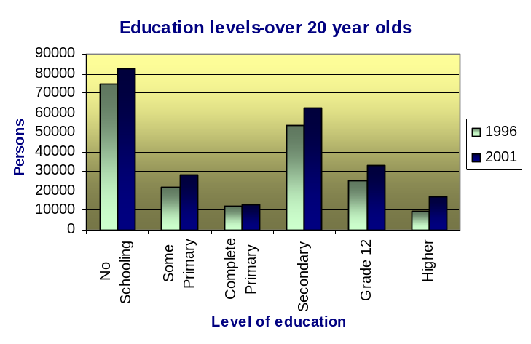
  Persons | 1996 | 2001
  No Schooling | 38.0% | 34.9%
  Some Primary | 11.2% | 12.0%
  Complete Primary | 6.2% | 5.5%
  Secondary | 27.0% | 26.4%
  Grade 12 | 12.9% | 14.0%
  Higher | 4.7% | 7.2%
Source: Municipal Demarcation Board, 2001

EMPLOYMENT BY ECONOMIC SECTOR

The distribution of the formal sector of the labour force by economic sectors in Makhado Municipality is illustrated in Figure 5.7 below.

Figure 5.7: Labour force per industry
Economic Sector | 1996 | 2001
Agriculture/ Forestry/ Fishing | 17.9% | 16.5%
Community/ Social/ Personal | 22.0% | 26.7%
Construction | 8.4% | 6.3%
Electricity/ Gas/ Water | 1.4% | 0.9%
Financial/ Insurance/ Real Estate/ Business | 4.2% | 5.5%
Manufacturing | 5.5% | 5.9%
Mining/ Quarrying | 0.4% | 0.2%
Private Households | 12.9% | 11.9%
Transport/ Storage/ Communication | 4.8% | 3.3%
Undetermined | 11.3% | 8.5%
Wholesale/ Retail | 11.1% | 14.1%

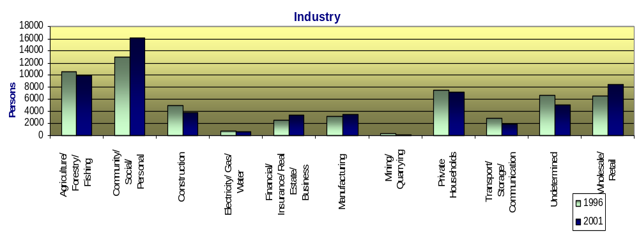
Source: Municipal Demarcation Board, 2001

The majority of Makhado’s population is occupied in the Community, Social and Personal industry. Secondly 16.5% of the population is involved in Agriculture, Forestry and Fishing. The province produces 75% of the country's mangoes, 65% of its papaya, 36% of its tea, 25% of its citrus, bananas and litchis, and 60% of its avocados, two thirds of its tomatoes and 285, 000 tons of potatoes. Other products include coffee, cotton, tobacco as well as timber with more than 170 plantations. Apart from these, there is sunflower, maize, wheat and grape cultivation (www.sehd.org.za).

There are also extensive tracts of forest in Limpopo, including plantations of pine and saligna. Timber processing in the form of sawmills has spawned active furniture, interior fitting as well as crate and pallet manufacturing industries (www.sehd.org.za).

DEVELOPMENT INITIATIVES

While the current economic conditions within the Makhado economy was discussed in the preceding paragraphs, it is vitally important to realize that a number of high level development interventions and initiatives are being planned and implemented in the local region. While the current state of these initiatives is not known precisely in Makhado, the potential impact of these initiatives on the local economy has to be taken into consideration. The following subsection presents a brief overview of a selected number of these development initiatives

MAKHADO MUNICIPALITY: TOURISM DEVELOPMENT AND MARKETING PLAN

At present, the Makhado Municipality does not have any set objectives regarding their expectations from the tourism sector, so this Tourism Development and Marketing Plan has suggested that the local objectives should be based on the Provincial Tourism Growth Strategy. This Strategy calls for a doubling of the contribution that the tourism sector makes to the Provincial economy over the next five years.

The Marketing Plan is founded on growth objectives and the rationales behind the various steps that constitute an effective marketing strategy. The plan also describes what are likely to be the main developments and trends within the tourism industry in the 21st Century, and this information is offered in the hope that it will be of value in helping to understand that certain issues, such as the rapid advances in technology, should not be feared but must rather be embraced and orchestrated to the benefit of the local industry. The plan also highlighted that there is major growth in theme parks and ‘simulated’ wildlife and nature-based experiences in and around major urban centres such as Johannesburg and Tshwane and these projects may siphon off a high percentage of those people who may, otherwise, have been potential visitors to an area such as the Soutpansberg. However, at the same time, it is noted that there is huge growth in niche and special interest markets and these are segments that should be targeted in both the development and the marketing strategies for the future.

The marketing plan also proposes that the focus should be on strengthening and supporting the existing initiatives such as the three main ‘routes’ in the area, as this would be the fastest way of increasing the flows of repeat and new visitors into the region. It is also recommended that there should be a focus on additional events as these stimulate, not only immediate economic returns, but they also serve to expose the attractions of the area to new markets.

The marketing plan also comments on the need for the industry itself to have a ‘code of ethics’ and to adopt an appropriate number of the Responsible Tourism Guidelines that will not only hold commercial advantages for the operators, but will also give the operators and the region the necessary recognition as a ‘people’ and ‘environment’ friendly destination. It is noted that the issue of a BEE Scorecard is likely to be compulsory for all tourism operators, but certain guidelines dealing with staff empowerment have been recommended for adoption in the Makhado area at the earliest opportunity. The plan indicates that there are a growing number of tourists and tour operators around the world who are seeking operations and destinations that do have meaningful and measurable environmental and social outreach programmes, and the adoption of a Responsible Tourism Scorecard would give the Makhado destination a distinct competitive advantage (Makhado Local Municipality Tourism and Marketing Strategy Plan, 2003).

LIMPOPO GROWTH AND DEVELOPMENT STRATEGY

The purpose of the Limpopo Growth and Development Strategy (LGDS) is to provide a vision for development that reflects the priorities and competitive advantages of the Province, but that is also consistent with national development achievements during the past decade is provided.

The LGDS will be informed by existing policy at the national, provincial and local levels and should also be the point of reference for future development policy and integrated development plans. This implies that the LGDS has to be continuously revised

IMPLICATIONS FOR MAKHADO

The LGDS aims to facilitate Economic Growth which will produce employment opportunities whilst maintaining existing services and addressing backlogs. It will further strive to develop infrastructure and maintain existing infrastructure and to build administration. In other words, the implications for Makhado can be summarised as follow:

Above average economic growth rate
Increase in investments
Job creation
Equitable distribution of resources
Healthy and fair trade
Thriving SMMEs in all sectors
Sustainable development through sound environmental management

CONCLUSION

The local economy of Makhado is performing well when compared to the surrounding economies. A critical concern is that although Makhado Local Municipality is the driving economy in Vhembe District Municipality, its percentage annual growth rate declined from 4.0% to 2.9% from 1993 to 2003. This illustrates the need for local economic development that will broaden the economic base and increase economic growth. However, the Wholesale & retail trade, Agriculture, forestry and fishing, and Manufacturing sectors should be stimulated to facilitate higher levels of economic growth and development because they have a comparative advantage and have experienced sectoral growth. .

A key objective of any economic development intervention in the local economic environment should focus on stimulating local value adding activities. This translates into the stimulation of the manufacturing sector.

The agriculture sector should receive attention that is of such nature that the stimulation of this employment creation sector formally utilizes and develops the economic linkages in the form of increased local beneficiation of raw produce. This directly implies that the international/export markets should be targeted.

While the analysis does not directly include tourism as a sector, as this is a quaternary sector and consists of elements within the investigated sectors such as trade and transport, the inclusion of tourism related activities must be incorporated. The rationale for this is based on the fact that tourism has the ability to act as a stimulant and catalyst for employment creation and economic growth.

The following chapter investigates the salient features of the business audit throughout Makhado. The emphasis of the next chapter is on the findings of the business audit and other economy-related characteristics. The Makhado communities are faced with declining opportunities to undertake fitting work to obtain income. This has lead to a rapid growth in the number of informal sector activities. Specific activities need to be undertaken in order to formalise the informal sector; stimulate transformation of the informal sector to become sustainable formal businesses; provide appropriate SMME development activities; and support existing SMMEs to retain employment opportunities and create additional employment demand.

Furthermore, the skills levels, and associated employability of the local communities need to be improved. However, the skills development should be of such nature that the supply of skilled labour aligns with the demand for specific skills from the formal business sector. The skills development initiatives should also align with the informal business needs and requirements.

